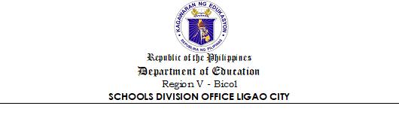

TO WHOM IT MAY CONCERN:

I HEREBY CERTIFY, under oath that I have actually enrolled in the schools listed in the accompanying transcript of records and that I have actually earned the units indicated therein. As required, the BUREAU OF HIGHER EDUCATION has been furnished with authentic copies of this statement and its enclosure.

_____________________
Affiant

SUBSCRIBED AND SWORN TO before me this _______ day of _____________, 202_, affiant exhibited to me her/his Residence Certificate No. ______________. Issued at ____________________ on ____________________, 2024.

`

_________________________
Administering Officer

